Name:
Label the following parts of the eye:
Retina, Lens, Optic Nerve, Vitreous Humor, Cornea, Blind Spot
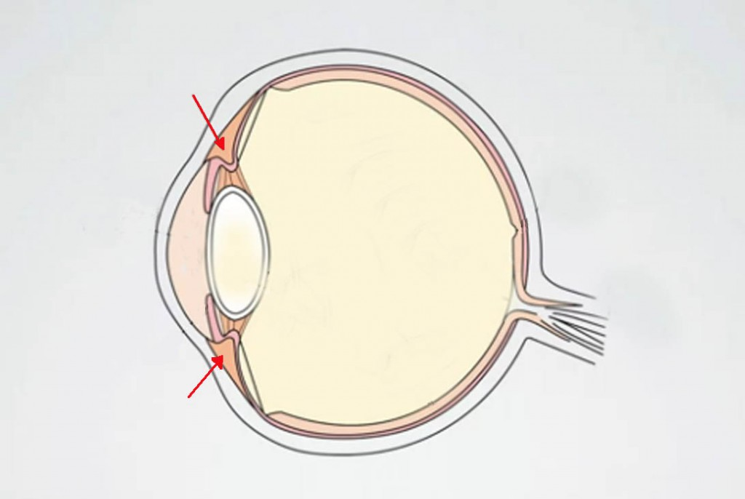

- Explain in detail why we have a blind spot:

- How much of your field of vision is taken up by the blind spot? How do you know?

- What shape is the blind spot? How do you know?

- How might this blind spot be a problem for drivers? How else might it affect a person’s life? How could the blind spot affect your life?

