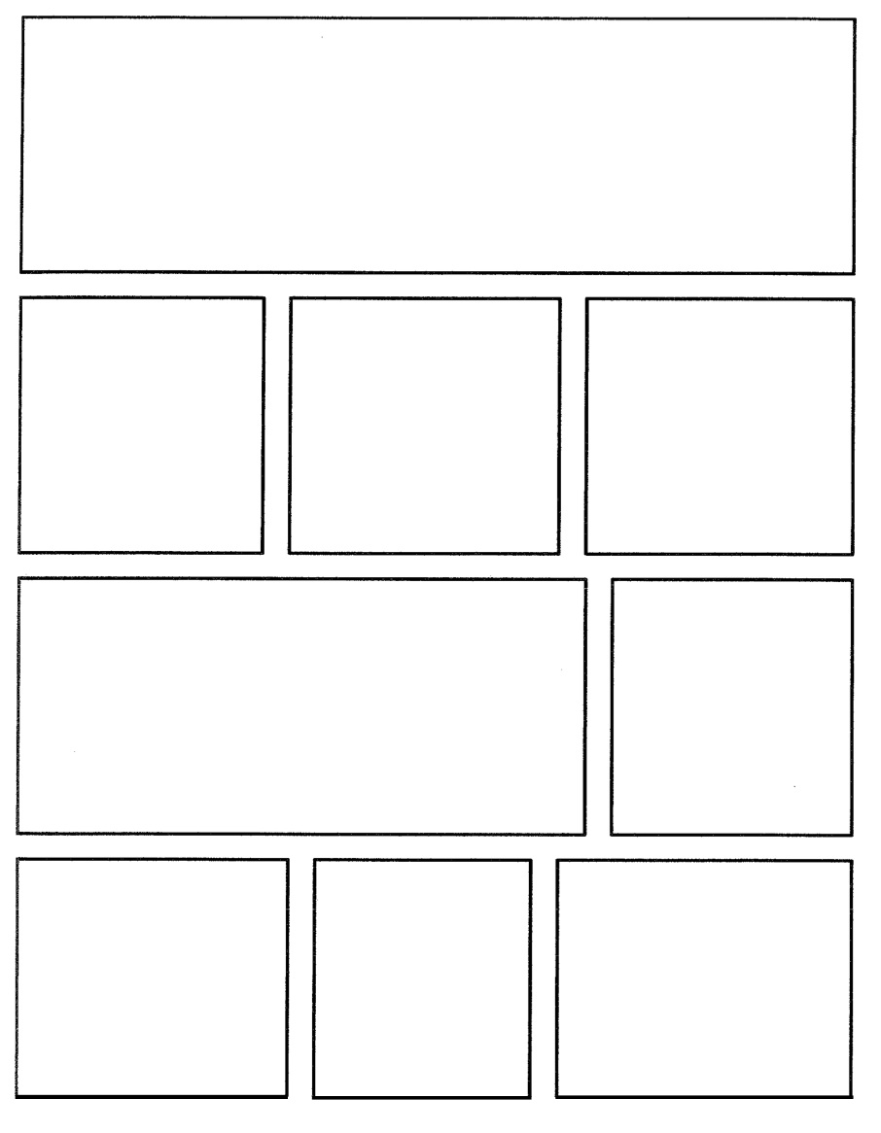

Name:
Pandora’s box comic

In craft art this week, we are reading the myth of Pandora’s box and making our own collage boxes. For homework, please recreate the Pandora’s box myth using this comic strip outline. Include all major events from the story.

